**Cloud Trail**

------------------

It’s an auditing service.

In IAM, we have learnt how to create users, groups, assign users to groups etc.

Let’s Say, someone has deleted S3 bucket?

How to know, which users has done this?

At what time, it has happened?

We can track this information using cloud trail.

All the activities can be tracked by user using cloud trail.

Services -- CloudTrail

Select event history

Observation: We can see the records of the events which we have performed.

Select a particular event, we can get more detail information.

We can apply filters

**Filter:** Resource type Bucket

We can see the events related to the S3 Bucket

We can apply filter based on time period.

We can download the list of events.

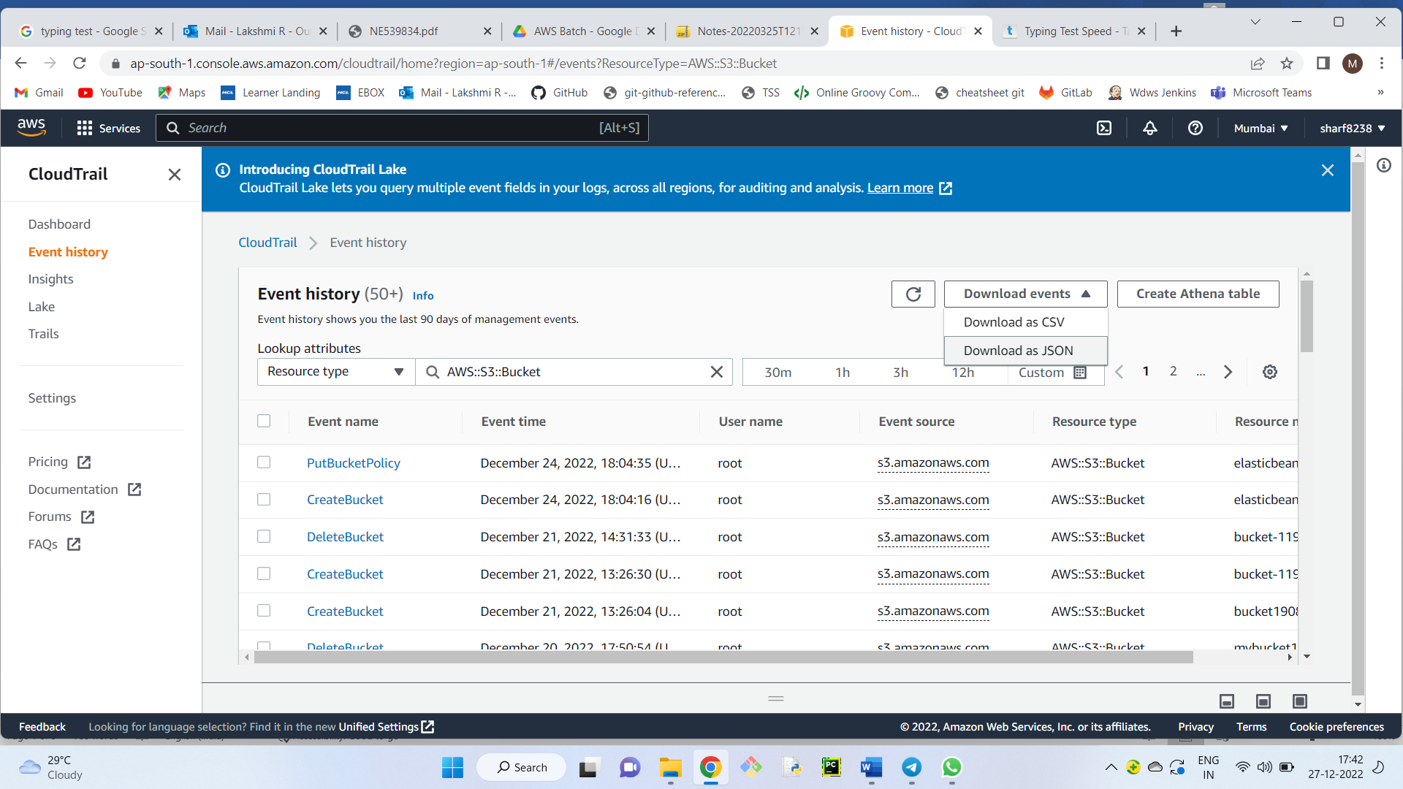

Note: Root user can see the Event history.

IAM users will not have access to see the event history.

+++++++++++++++++++++

+++++++++++++++++++++

**Cloud Formation**

---------------------------

3 Ways to create AWS Infrastructure

1) GUI

2) CLI

3) IAC (Infrastructure as Code)

Code is written in JSON/Yaml script

When we run the code infrastructure will be created.

**Advantages:**

------------------------

We can store the code in S3 for repeated execution

We can have version controlling

**Practical:**

-----------------

Services -- Management and Governance -- CloudFormation

Create Stack -- Create Template in designer

Select Templates tab (Select YAML radio button)

Under Resource Types - select EC2 --- Ec2Fleet -- Drag and drop in the right-side frame.

We get the YAML code

-------------

Let’s go back and select sample template

Select LAMP Stack --- (select view in designer to see the code - new tab)

Next -- Stack Name - MyStack

DB Password - welcome

DBRootPassword - welcome

DBUsername - welcome

Keyname – is the existing keypair

Next --- Tags -- Name: LAMP Stack --- Next --- Create Stack

(We should be able to see Webserver, security group.

In Webserver, PHP and MySQL will be installed)

-----------

Go to Services -- Ec2, We can see one EC2 machine gets created.

Go to security group - One Security Group is also created.

---------------

In stack details dashboard -- outputs

We get website URL (This is nothing but DNS name to the EC2 Machine)

Open the URL

We get the default website.

===================

**What is terraform?**

It is similar for CloudFormation.

By using terraform, we can create AWS / Azure / GCP Infrastructure.

It used "hcl" language

------------------

Deletion process

-------------------

Delete the stack, complete infrastructure gets deleted.

(EC2 Machine is terminated, Security group is also deleted)

+++++++++++++++++++++++++++++______________+++++++++++++++

**Elastic BeanStalk**

Mainly used by developers

Developers write the code for creating application.

For testing the code, developers needs Machine (Ec2 instance)

Developers are not inclined/ preferred to create infrastructure.

The solution for developers is ElasticBeanStalk.

Developers write the code, they upload the code into ElasticBeanStalk.

Infrastructure will be created automatically for testing the application.

Objective of CloudFormation is to create Infrastructure

Objective to ElasticBeanStalk is to test the application

Practical:

-----------------

Services -- compute -- Elastic Beanstalk

Get started

Application Name - MyApp

Platform - PHP

Select Sample Application

Create Application (It will take few min) Hit refresh in Ec2 dashboard.

Ec2 machine is created, code will be deployed into the Ec2 Machine.

Observation: Security group will also be created with the Application Name.

How we can see the website,

in MyApp dashboard -- We get environment ID and Application URL

++++++++++++

Deleting the Application

In All Applications

Actions -- Delete Application.

Automatically EC2 and Security groups will be deleted.

++++++++++++++++++

---------------------------------

**Snowball**

----------------

It is a data migration service.

Let’s Say, you have 1 TB of data.

You need to migrate 1 TB data to S3 bucket.

Assume, it takes 1 hr time to migrate.

If the data is 100 TB?

If the data is 1000 TB (1 zeta byte)

If the data is 100 ZB?

If the data is 1000 ZB? (1 peta byte)

If the data in 100 PB - It takes years to load the data.

Ex: Facebook, will have huge amount of data

The solution is snowball

There are three variants in snowball

1) snowball

2) snowball edge

3) snow mobile

1) snowball

---------------

It’s a physical hard disk, AWS will send to the clients location.

The size of the snowball will be 80 TB

Search in google "aws snowball" we can see the image of the snowball.

2) snowball edge

--------------------------

The size is 100 TB

Snowball edge contains compute capacity.

It comes with display (similar to mobile phone)

We can edit, delete from the display.

Use case: National Geographic Channel

will take snowball edge to forest shoots etc

Search in google "aws snowball edge"

3) snow mobile

--------------------------

The size is 100 PB

It’s like truck.

Search in google "aws snowball mobile"

+++++++++++++++++